**IFT 259 Introduction to Internet Networking**

**Lab 11**

**Usable Host Range Investigation**

Co-authored by Brandon Clifford

**After you complete each step, put a ‘√’ or ‘x’ in the completed box   
or**

**Complete the free response section**

**or**

**Attach screenshots where requested**

1. Set up the following topology in packet tracer.

**Done**

1. We will now configure the router by entering some basic commands (we will do more programming of the router is future labs).  
     
   Click on the router and then go to the config tab, type ‘no’ when as to ‘continue with configuration dialog’ and enter the following commands after your press the return button to get started.

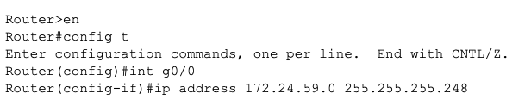

done

You should have received this error



Why was this error produced?

___________________Because of range of host___________________________________

What is the valid host range for the 255.255.255.248 subnet?

_________________________249-254_________________________

1. Now accounting for the valid host range, enter in the correct commands for this scenario’s router

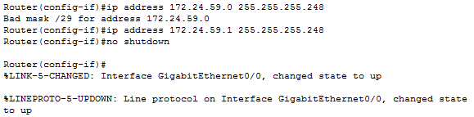

**N.B The ‘no shutdown’ command turns on the router interface**

**done**

1. Your topology should be entirely connected with all ports up (all green) at this point



done

1. Configure PCs 0 – 4 incrementally starting with the IP address 172.24.59.2 (subnet mask of 255.255.255.248 for all PCs)

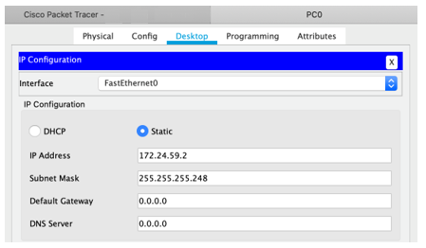

done

1. Now try to configure PC05’s IP address with 172.24.59.7, why won’t Packet Tracer allow you to set this IP address?

_______________________Invalid IP for this subnet mask entered________

1. What is the usable host range for 172.24.59.0 255.255.255.248?

____________________1-6_________________________________

1. You should have realized that 172.24.59.7 is the broadcast address for this subnet mask and is outside of the usable host range.  
     
   It is critical to understand which subnet mask will work best for the IP addresses you will be assigning in a network, and to realize that your choice matters when it comes to efficiently utilizing IP addresses.



done

1. You should be able to ping any other computers with an IP address in the usable host range for this subnet mask at this point  
     
   Attach a screenshot of a ping to any computer in this this network to verify connectivity and understanding of usable host ranges

